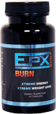
EPX Body For Life! We started the EPX Body Burn about 4 months ago and Perry has lost about 35lb. He has diabetes and since taking the EPX Body Burn his blood sugar has gone down. So now instead of taking the 4 shots per day he used to take he only needs to take 1 shot per day.
Now as for me when I started it I was a size 20 and as of today 9/21/12, I have gone down to a size 14. I now can get back into my suits that have been packed away since 2003 because I had gotten too big to wear them. We are both truely happy with the results from EPX Body Burn and all of my coworkers and friends now want to know what we have been doing to lose so much weight and of course we are just to happy to tell them EPX Body and point them to our website.

. ~ Perry & Mary Keller ~ Washington USA
These are products that people need! Everyone needs at least one of these and I am excited about this opportunity and have lost 5 pounds on the EPXBody burn in just 4 days! ~ Shan M. ~ Mississippi USA


Finally, the winning formula. A company with the right products at the right price, and team that maximizes the compensation plan marketing for you. The EPXBody burn has my energy levels off the charts, and the possibilities of the compensation plan has my excitement level off the charts. Great products, free advertising, free websites and marketing systems; what else do you need. Sign up, get started and get paid. ~ Rowland Webb ~ VIrginia USA ~
Get back to the person who told you about EPXBody and tell them that you are ready to take on the 90 day challenge.




For more information:
Visit: http://www.getepx90.com/Elitebuilder
Email amservices@ymail.com
or Contact: Anthony Green
Tel: (246) 232-0200

EPX Body was founded in March 2012 by Dan Putnam, a highly successful network marketer with an impressive career. EPX Body is headquartered in Layton, Utah and is fully launched and primed for expansion.

SOME OF THE COMPANY’S PRODUCTS!
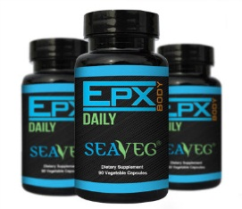
EPX DAILY – Benefits reported include:
• Promotes healthier skin • Fights Allergies • Removal of Toxins & Heavy Metals • Known to stabilize Blood Sugar • May inhibit Blood Clotting • Helps relieve Stomach Disorders • That’s why EPX Body Daily is 100% vegetable supplement that contains 12 edible species of sea plants, which are known to be packed with powerful nutrition and trace minerals.

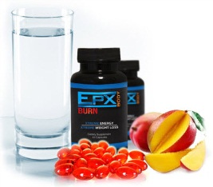
EPXBodyBurn – Benefits reported include:
• Suppresses appetite • Increases Energy • Shrinks Belly Fat • Speeds weight Loss • Burns Fat Fast but safely • Improves overall health • Increase metabolism. This is the product to get to be a part of our “paid to lose weight” challenge.

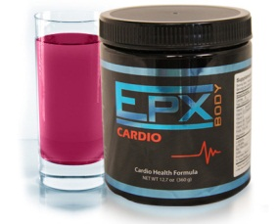
EPX Cardio – Benefits reported include:
• Improved cardiovascular health • Helps regulate blood pressure • Improves outcome of cancer treatment • Improves circulation • Lowers Cholesterol • Promotes healthy sexual function.

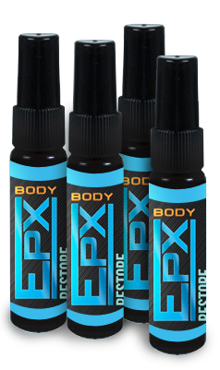
EPX Restore – Benefits reported include:
Stress reduction, • Increased sexual vitality. • Increased physical vitality, • Ability to concentrate better. • Greatly improved sleep & energy • Shortened recovery after workouts.
The EPXBody challenge is a very unique challenge and everyone can win because instead of just picking a couple winners we actually pay per pound lost. Look at the chart below to see how it works.
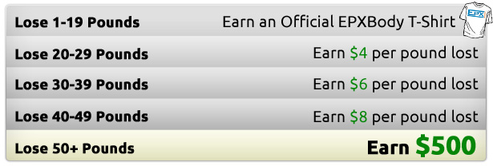
The EPXBody 12 week challenge was created to motivate YOU to make a positive lifestyle change, while transforming your mind-and your body. We include everything you need: Clean meal plan, a easy exercise program to follow, and amazing supplements.
You can start at anytime but the best time to start is right now! Simply pick one of our products packs starting at just $39.95 and then follow the simple directions listed on the company’s website.
ANYONE can do this! Busy moms, full time workers, students, etc. IF you are willing to follow the meal plans and use the supplements, you will be successful.
You can enter the challenge in any country we are shipping products to. The rules for registration are the same no matter what country you live in. So get started today.

