
EPXBody is a great opportunity with guaranteed products that work. This is the first time where I haven’t had to pay a sign-up fee or pay an additional fee for a website, capture page, auto-responder, contact manager, and website statistics. It’s all included with my monthly purchase of any one of the great products for $39.95. EPXBody is Amazing, thank you for an awesome opportunity! ~ Karen K. ~ California USA


After many years in the MLM business, this opportunity with EPX Body is the best I have ever seen. The cost of staying active in the program is the best I have seen. The EPX Body products are top quality and work as advertised. The features of the back office is second to none. It would almost be impossible to fail. The money I will make with this company will make my retirement more comfortable. ~ Al Napolitano ~ Maryland USA ~


Finally, the winning formula. A company with the right products at the right price, and team that maximizes the compensation plan marketing for you. The EPXBody burn has my energy levels off the charts, and the possibilities of the compensation plan has my excitement level off the charts. Great products, free advertising, free websites and marketing systems; what else do you need. Sign up, get started and get paid. ~ Rowland Webb ~ VIrginia USA ~
Get back to the person who told you about EPXBody and tell them that you want to become a part of this fantastic program.




For more information:
Visit: http://epxbiz.yolasite.com
Email amservices@ymail.com
or Contact: Anthony Green
Tel: (246) 232-0200

EPX Body was founded in March 2012 by Dan Putnam, a highly successful network marketer with an impressive career. EPX Body is headquartered in Layton, Utah and is fully launched and primed for expansion.

SOME OF THE COMPANY’S PRODUCTS!
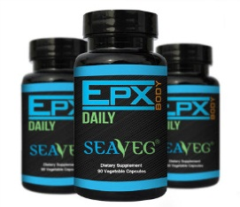
EPX DAILY – Benefits reported include:
• Promotes healthier skin • Fights Allergies • Removal of Toxins & Heavy Metals • Known to stabilize Blood Sugar • May inhibit Blood Clotting • Helps relieve Stomach Disorders • That’s why EPX Body Daily is 100% vegetable supplement that contains 12 edible species of sea plants, which are known to be packed with powerful nutrition and trace minerals.
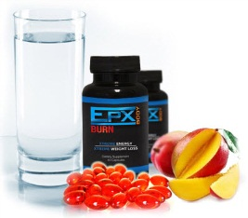
EPXBodyBurn – Benefits reported include:
• Suppresses appetite • Increases Energy • Shrinks Belly Fat • Speeds weight Loss • Burns Fat Fast but safely • Improves overall health • Increase metabolism. This is the product to get to be a part of our “paid to lose weight” challenge.

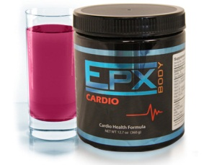
EPX Cardio – Benefits reported include:
• Improved cardiovascular health • Helps regulate blood pressure • Improves outcome of cancer treatment • Improves circulation • Lowers Cholesterol • Promotes healthy sexual function.

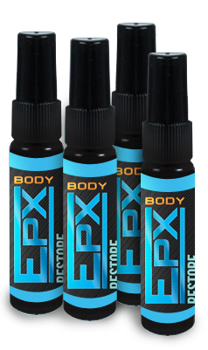
EPX Restore – Benefits reported include:
Stress reduction, • Increased sexual vitality. • Increased physical vitality, • Ability to concentrate better. • Greatly improved sleep & energy • Shortened recovery after workouts. 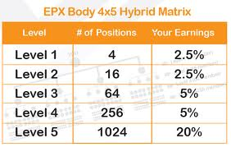 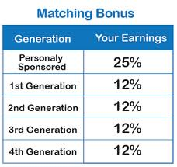
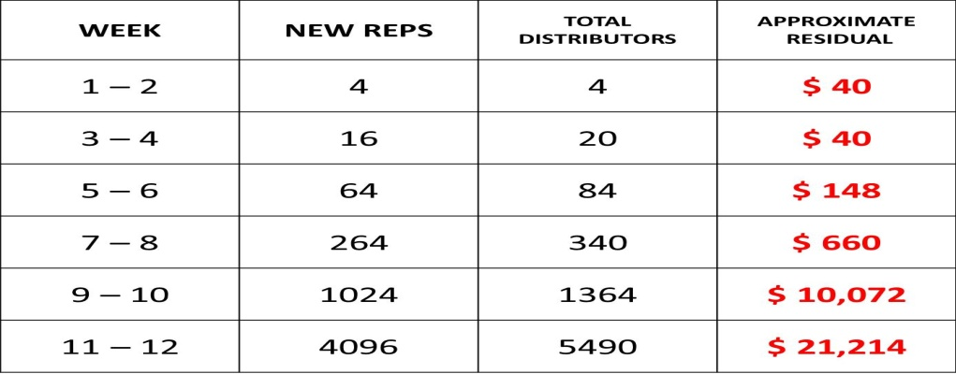

This is just an example of the income potential with this business and there is no guarantee. This is for example only.

